**1.Important Points in Practicum**

**1.1Objectives of the Practicum**

* provides the opportunity to integrate and apply classroom learning
* enabling the intern to observe and learn from professionals in the field
* providing an introduction to the practical skills and experience necessary for a productive and fulfilling career

**1.2Guidelines / Policy before Practicum**

* Before being deployed, interns must submit prerequisites such as a recommendation letter, waiver, and acceptance letter.
* Interns must arrive 15 minutes before the start of work.
* Interns are expected to dress professionally. Interns should avoid wearing distracting apparel that is too exposing, tight, or low-cut. The practicum uniform is required for interns.

**2.The Workplace**

This chapter contains brief history/ important information about the workplace. It is divided into (3) Three profiles; Company Profile, Department Profile and Product/Services description of the Company/Department.

**2.1Company Profile**

The Company Profile will focus at Bestlink College of the Philippines: History, Mission and vision, Core Values and the Organizational Chart of the Company

**2.1.1 Company History**

The school was established in June 2002 at Sacred heart Village, Caloocan City by the generous and charitable Madame Mary M. Vicente, president, and Engineer Reynaldo Corpuz, administrator. The school was initially named "LOG ON TODAY," but the management later on decided to change it, as it literally sounded like an internet cafe. Inspired by the phrase, "Be trained to be the best, be linked to success," BESTLINK came out to be more appropriate. Since Bestlink offers computer-based courses, it was eventually decided to name the BESTLINK INSTITUTE OF INFORMATION AND TECHNOLOGY. With its mission and vision of providing holistic training TESDA-accredited Bestlink started with four computer courses. These are Computer System Design and Programming, Computerized Office management, Computer technology and Networking, and Computer Graphics and Web Development. Bestlink started its operations with seven students: five from Computerized Office Management and two from Computer System Design and Programming. Its first location did not appeal positively to public patronage, so the school did not attain the expected number of students. Bestlink started its operations with seven students: five from Computerized Office Management and two from Computer System Design and Programming. Its first location did not appeal positively to public patronage, so the school did not attain the expected number of students. During that time, Bestlink had only four faculty members: Engr. Reynaldo Corpuz, math instructor and administrator; Mr. Vincent Carlo Garados, computer instructor and IT coordinator; RespicioSiringan, English instructor; and Ms. MarimelLoya, office management instructor, cashier, and student affairs and marketing coordinator.

In 2004, Bestlink, with its new administration headed by Engr, Diosdado T. Lleno, school director, decided to move to its new location at 1044 Brgy. Sta. Monica Quirino Highway, Novaliches, Quezon City. This strategic location led to a huge increase in the number of students.

In 2005, through the persistent efforts of Engr. Lleno, and Mr. Charlie Cariño as the academic consultant, Bestlink offered an additional course, Hotel and Restaurant Commercial Cooking, Food and Beverage Service, Housekeeping, Bartending, Baking and Pastry, Tour Guiding, and Front Office Services.

In 2007, with the continuous increase of students, Bestlink temporarily held its classes at Annex 1 fronting the Main Building. The following year, the school acquired three lots adjacent to Greenfield's I Subdivision. On the first lot stood a two-story building which used to be a bank. This was improved by Bestlink, such that the ground floor served as the administration office and the second floor housed the school library. On the second lot, the original structure was remodeled into a mock hotel to suit the needs of the school as well as serve as a training facility for HRS students. A five-story building was constructed on the third lot to provide the increasing number of enrollees with quality facilities in line with its vision of providing quality education. A new structure was added on the vacant space to serve as a cooking lab-training room for HRS students. The HRS laboratory and other facilities were transferred to the newly built mock hotel which was inaugurated in August 2008. Due to its continuing expansion, Bestlink started to offer the CHED laddered program (4-year degree courses): BSIT, BSHRM, BSOA, and BSBA major in Marketing and Human Resource Management. The Permit to Operate (PTO) for the first two courses was granted by CHED in 2009 and the last two courses in 2010. The school opened a vast campus in Millionaire’s Village in Novaliches, Quezon City, where now stand towering edifices that are quite a revelation of the strength and stability of the school, enough to dwarf other colleges around with its outshining size and pervasive presence.

**2.1.2Company Mission and Vision**

The Bestlink College of the Philippines has a mission and vision that the BCP students must know.

**Mission**

To produce self-motivated and self-directed individuals who aim for academic excellence, God-fearing, peaceful, wealthy, productive and successful citizens.

**Vision**

Bestlink College of the Philippines is committed to provide and promote quality education with a unique, modern and research-based curriculum with a delivery system geared towards excellence.

**2.1.3Company Core Values**

Bestlink College of the Philippines’ core values are faith, knowledge, charity and humility. Faith represents BCP’s endeavor for expansion, development and growth amidst the global challenges of the new millennium. Knowledge connotes the institution’s efforts to impart excellent lifelong education that can be used as a human tool so that one can liberate himself/herself from ignorance and poverty. Charity is the institution’s commitment towards its clientless. Humility refers to the institution’s recognition of its human frailty, its imperfection.

**2.1.4Company Organizational Chart**

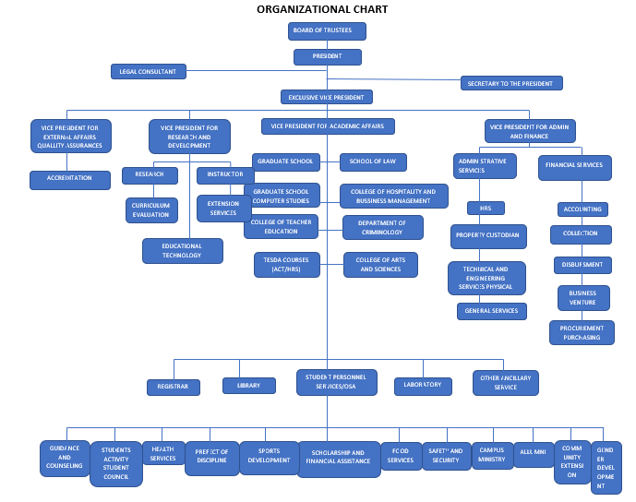

**2.2Department Profile**

The Department Profile will focus on the history, aim, and vision of the Safety and Security Department, as well as the company's basic principles and organizational structure. The purpose of this document is to enlighten students about the school's safety and security rules and procedures. It also acts as a manual for the company's step-by-step procedures in numerous rules and regulations.

**2.2.1Department History**

The Safety and Security Office was created by Commission on Higher Education under the Student-Personnel Services Program. The office is mandated to make sure that all guidelines are being followed especially on our desire to prevent any accident to occur. The Safety and Security Office has the primary responsibility of all matters regarding the school's security therefore making all the necessary procedures to enhance and improve the status of the school. The institution is required to have a school safety and security plan. Each plan must be designed locally with the help of the safety and security officers, administration of the school, guidance counselors, health officials and all other key stakeholders. All plans must be reviewed and updated on an annual basis. These plans include procedures to respond to critical incidents ranging from bomb threats, fires, earthquakes, gas leaks or any accident that may occur, to any situation. The Bestlink College of the Philippines is upholding the safety of its stakeholders – students, teaching and the non- teaching personnel, staff, and otheremployees for a safer and secured leaming and working environment.

**2.2.2Department Mission and Vision**

**Vision:**

To achieve high standards of professionalism while dedicated to the principles of integrity, responsibility and accountability in providing a safe and secured learning and working environment to the entire BCP.

**Mission:**

To provide safe, secured and healthy learning and working environment to the entire BCP community.

**2.2.3Department Core Values**

One of the essential ideas of the safety and security is increasing internal and external trust, to accept responsibility for your actions. Which is a crucial business practice to conduct in a transparent, and trustworthy manner, which earns the respect of colleagues, customers, and the public. If interns are passionate about their career and the people around them, they can be brave, inventive, and creative.

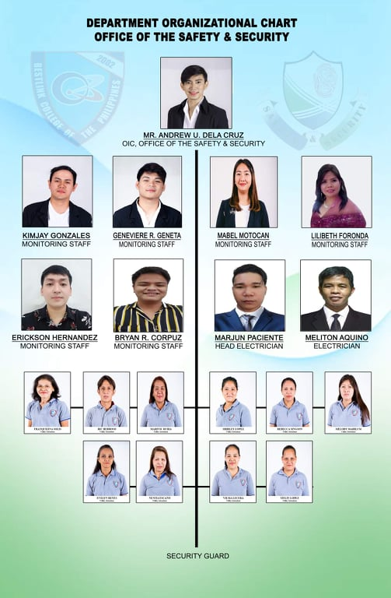**2.2.4Department Organizational Chart**

**2.3Product / Services Description**

**2.3.1Company / Department Logo and Its Meaning**



Safety and Security logo

The Safety and Security Office is in charge of all things concerning the school's security and is responsible for implementing all necessary measures to strengthen and improve the school's status. The institution is required to have a school safety and security plan.

Bestlink college logo

The logo represents the school's commitment to providing and promoting high-quality education using cutting-edge technology in order to improve our students' skills and knowledge in order to make them globally competitive and productive citizens.

**2.3.2Company / Department Partner / Affiliation**

**2.3.3Company / Department Target Clientele**

Bestlink College of the Philippines (BCP) is a non-sectarian, private, non-stock, non-profit educational institution. The Admission and Information Department is responsible for providing correct information and ministering to the thousands of students who enroll in Bestlink College of the Philippines (BCP) each school year. The department is in charge of enrollees from first to fourth year, particularly first-year students and returnees.

**2.4Location of Company**

Bestlink College has a (4) campus, Main Campus, Millionaire Villages (MV) Campus, Bulacan Campus, San Agustin Campus.

I’m assigned at Main Campuswherein located at #1071 Brgy. Kaligayahan, Quirino Highway Novaliches Quezon City, Philippines 1123.

**2.5Thrusts and Policy Direction**

* For the protection of the students and personnel, interns must wear a mask and face shield.
* When interns arrive at the school, they must show identification.
* Most of the time, social separation is required.

**2.6Company Rules and Regulations**

* Interns are expected to arrive on schedule.
* Interns must dress appropriately; formal attire is not required owing to the weather outside the office.
* Before interns take a leave, they must inquire the day before.
* The interns must not respond with "I don't know," because the interns should know what to answer as much as possible.

**3. Activity Report**

**3.1Daily Accomplishment Report**

|  |  |  |  |  |
| --- | --- | --- | --- | --- |
| **DAY** | **DATE** | **OFFICIAL TIME** | **DAILY ACCOMPLISHMENTS** | **NO. OF WORKING HOURS** |
| Monday |  |  |  |  |
| Tuesday | March 8, 2022 | 10:00 am | - Cleaning the office  - Checking the receipt of student | 7 Hours |
| Wednesday |  |  |  |  |
| Thursday | March 10, 2022 | 8:00 am | - Checking the documents of education Department  - Monitor the visitor | 9 Hours |
| Friday |  |  |  |  |
| Saturday | March 12, 2022 | 8:00 am | - Arrange documents of student  - Cleaning the office | 9 Hours |

**3.2 Daily Accomplishment Report**

|  |  |  |  |  |
| --- | --- | --- | --- | --- |
| **DAY** | **DATE** | **OFFICIAL TIME** | **DAILY ACCOMPLISHMENTS** | **NO. OF WORKING HOURS** |
| Monday | March 1, 2022 | 8:00 am | - Cleaning books and Thesis book  - Verify the grades of student | 9 Hours |
| Tuesday | March 15, 2022 | 8:00 am | - Monitoring of visitor  - Check the filename of documents | 9 Hours |
| Wednesday | March 16, 2022 | 8:00 am | - Print the class schedule of teachers  - Creating the Schedules of teachers | 9 Hours |
| Thursday | March 17, 2022 | 8:00 am | - Copy the format of salary tables  - Photocopy the documents | 9 Hours |
| Friday |  |  |  |  |
| Saturday |  |  |  |  |

**3.3 Daily Accomplishment Report**

|  |  |  |  |  |
| --- | --- | --- | --- | --- |
| **DAY** | **DATE** | **OFFICIAL TIME** | **DAILY ACCOMPLISHMENTS** | **NO. OF WORKING HOURS** |
| Monday |  |  |  |  |
| Tuesday |  |  |  |  |
| Wednesday |  |  |  |  |
| Thursday | March 24, 2022 | 8:00 am | - Input of books in 1st year second semester in bsoa students. | 9 Hours |
| Friday | March 25, 2022 | 8:00 am | - Input of books in 2nd year second semester in bsoa students. | 9 Hours |
| Saturday |  |  |  |  |

**3.4 Daily Accomplishment Report**

|  |  |  |  |  |
| --- | --- | --- | --- | --- |
| **DAY** | **DATE** | **OFFICIAL TIME** | **DAILY ACCOMPLISHMENTS** | **NO. OF WORKING HOURS** |
| Monday | March 28, 2022 | 8:00 am | - Input of books in 2nd year second semester in bshm students. | 9 Hours |
| Tuesday | March 29, 2022 | 8:00 am | - Input of books in 2nd year second semester in BSED students. |  |
| Wednesday | March 30, 2022 | 8:00 am | - Input of books in 2nd year second semester in BSIT students. |  |
| Thursday |  |  |  |  |
| Friday |  |  |  |  |
| Saturday |  |  |  |  |

**3.5 Daily Accomplishment Report**

|  |  |  |  |  |
| --- | --- | --- | --- | --- |
| **DAY** | **DATE** | **OFFICIAL TIME** | **DAILY ACCOMPLISHMENTS** | **NO. OF WORKING HOURS** |
| Monday |  |  |  |  |
| Tuesday |  |  |  |  |
| Wednesday |  |  |  |  |
| Thursday |  |  |  |  |
| Friday | April 1, 2022 | 8:00 am |  | 9 Hours |
| Saturday |  |  |  |  |

**3.6 Daily Accomplishment Report**

|  |  |  |  |  |
| --- | --- | --- | --- | --- |
| **DAY** | **DATE** | **OFFICIAL TIME** | **DAILY ACCOMPLISHMENTS** | **NO. OF WORKING HOURS** |
| Monday |  |  |  |  |
| Tuesday |  |  |  |  |
| Wednesday |  |  |  |  |
| Thursday | April 7, 2022 | 8:00 am |  | 9 Hours |
| Friday | April 8, 2022 | 8:00 am |  | 9 Hours |
| Saturday |  |  |  |  |

**3.7 Daily Accomplishment Report**

|  |  |  |  |  |
| --- | --- | --- | --- | --- |
| **DAY** | **DATE** | **OFFICIAL TIME** | **DAILY ACCOMPLISHMENTS** | **NO. OF WORKING HOURS** |
| Monday | April 11, 2022 | 8:00 am |  | 9 Hours |
| Tuesday | April 12, 2022 | 8:00 am |  | 9 Hours |
| Wednesday | April 13, 2022 | 8:00 am |  | 9 Hours |
| Thursday |  |  |  |  |
| Friday |  |  |  |  |
| Saturday |  |  |  |  |

**3.8 Daily Accomplishment Report**

|  |  |  |  |  |
| --- | --- | --- | --- | --- |
| **DAY** | **DATE** | **OFFICIAL TIME** | **DAILY ACCOMPLISHMENTS** | **NO. OF WORKING HOURS** |
| Monday |  |  |  |  |
| Tuesday | April 19, 2022 | 8:00 am |  | 9 Hours |
| Wednesday | April 20, 2022 | 8:00 am | Releasing Soa of students | 9 Hours |
| Thursday | April 21, 2022 | 8:00 am |  | 9 Hours |
| Friday |  |  |  |  |
| Saturday |  |  |  |  |

**3.9 Daily Accomplishment Report**

|  |  |  |  |  |
| --- | --- | --- | --- | --- |
| **DAY** | **DATE** | **OFFICIAL TIME** | **DAILY ACCOMPLISHMENTS** | **NO. OF WORKING HOURS** |
| Monday | April 25, 2022 | 8:00 am |  | 9 Hours |
| Tuesday |  |  |  |  |
| Wednesday | April 27, 2022 | 8:00 am | Releasing Soa of students | 9 Hours |
| Thursday |  |  |  |  |
| Friday |  |  |  |  |
| Saturday |  |  |  |  |

|  |  |
| --- | --- |
| March 8, 2022 | - Cleaning the office  - Checking the receipt of student |
| March 10, 2022 | - Checking the documents of education Department  - Monitor the visitor |
| march 12, 2022 | - Arrange documents of student  - Cleaning the office |
| March 14, 2022 | - Cleaning books and Thesis book  - Verify the grades of student |

|  |  |
| --- | --- |
| March 15, 2022 | - Monitoring of visitor  - Check the filename of documents |
| March 16, 2022 | - Print the class schedule of teachers  - Creating the Schedules of teachers |
| March 17, 2022 | - Copy the format of salary tables  - Photocopy the documents |

|  |  |
| --- | --- |
| March 24, 2022 | - Input of books in 1st year second semester in bsoa students |
| March 25, 2022 | - Input of books in 1st year second semester in bsoa students. |
| March 28, 2022 | - Input of books in 1st year second semester in bstm students. |

|  |  |
| --- | --- |
| March 29, 2022 | - Input of books in 2nd year second semester in bstm students. |
| March 30, 2022 | - Input of books in 2nd year second semester in bstm students. |
| April 1, 2022 | - Input of books in 1st year second semester in bstm students. |
| April 7, 2022 | - Input of books in 1st year second semester in bstm students. |

|  |  |
| --- | --- |
| April 8, 2022 | - Input of books in 2nd year second semester in BA students. |
| April 11, 2022 | - Input of books in 2nd year second semester in BA students. |
| April 12, 2022 |  |
| April 13, 2022 |  |

|  |  |
| --- | --- |
| April 19, 2022 |  |
| April 20, 2022 |  |
| April 21, 2022 |  |
| April 25, 2022 |  |

|  |  |
| --- | --- |
| April 27, 2022 |  |
|  |  |
|  |  |
|  |  |

**3.2Performance Appraisal Report**

**4.Reflection**

**4.1Practicum Learning**

Interns learn how to implement the department's techniques in the real world during the practicum. Practicum emphasized in its employees the importance of hard effort and the worth of each task.

**4.2Problems Encountered**

Slow internet connections and unreliable service providers are important issues in implementing safety and security measures such as educator monitoring, which has a significant impact on students' learning.Employees also use antiquated computers for work, which frequently have problems, causing a lag in the employee's output.

**4.3Suggestion and Recommendation**

As a student who has firsthand experience with these issues, I recommend that the school provide a more reliable internet connection and a better working environment for its employees, which will not only result in better deliverables from its employees, but will also result in a safer and easier response to the safety and security concerns of its students, benefiting not only the students but also the institution.

**Appendices**

**Daily Time Record**

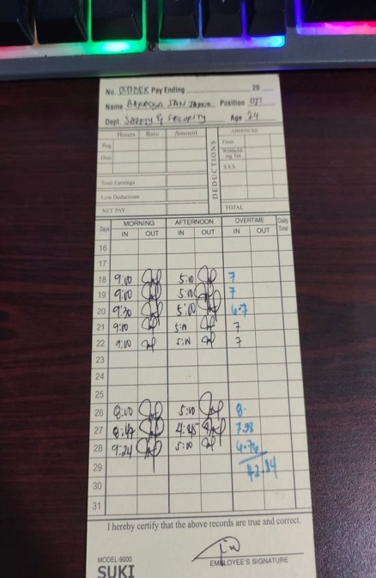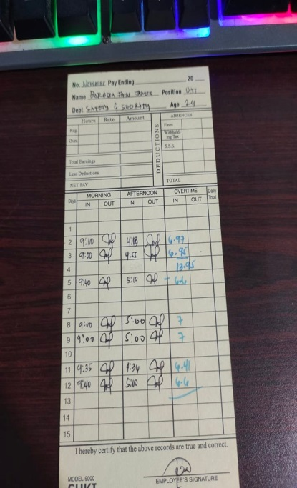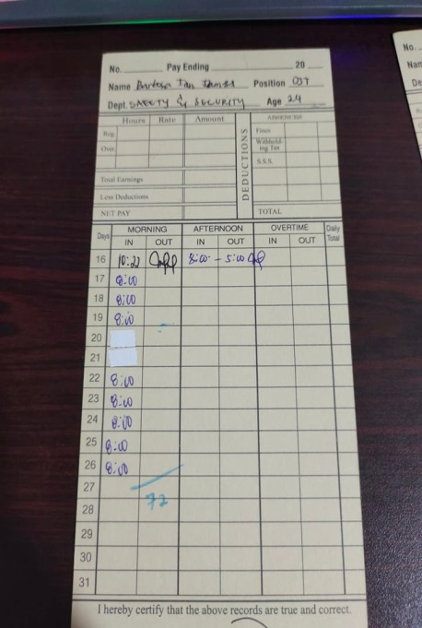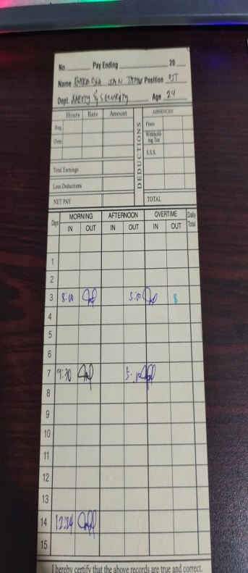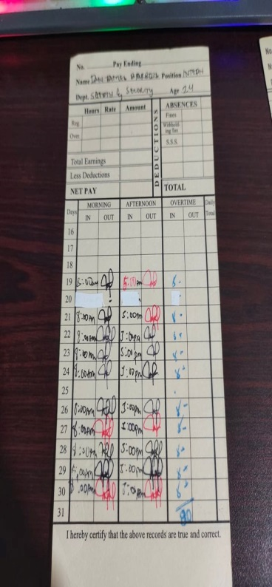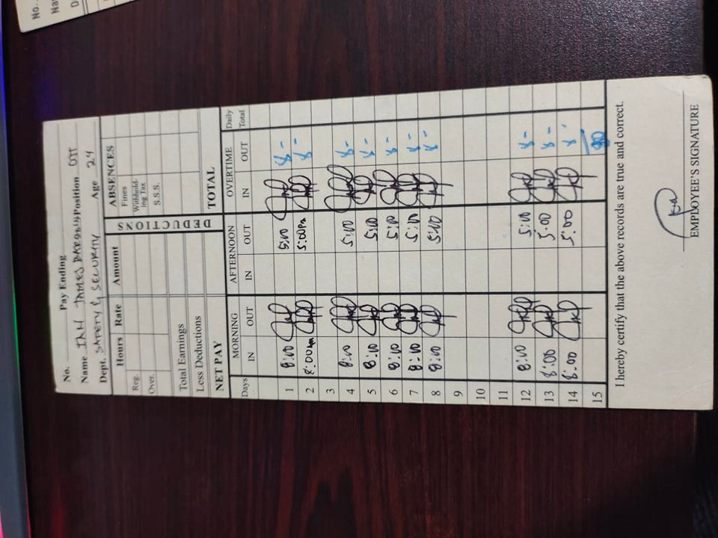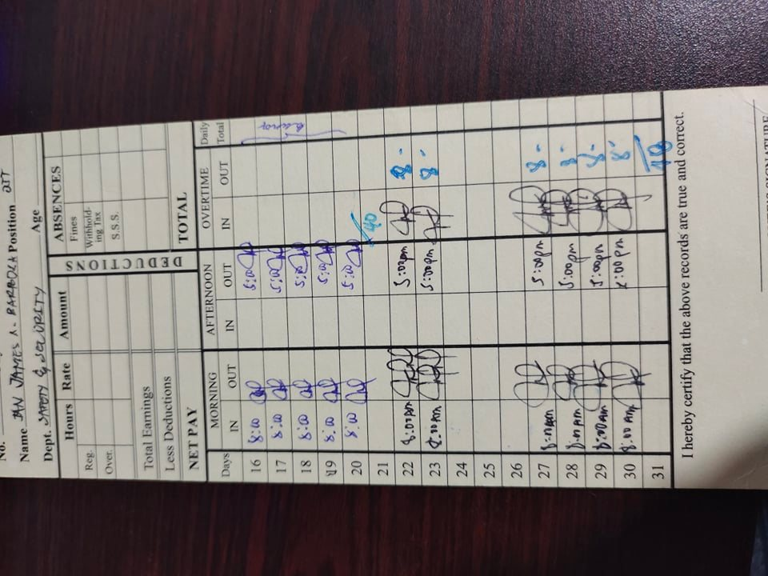

**Certificate of Completion**